**System Design Information**

**CSC301 : Sprint 1**

CRC Cards …………………………………………………………….Page 2 – 7

System Interaction …………………………………………………………Page 7

System Architecture ………………………………………………..….Page 8 – 9

System Decomposition …………………………………………………...Page 10

**CRC Cards**

**Class Name:** Official Game

Parent Class (if any): StateBasedGame (from Slick2D lib)

Classname Subclasses (if any): NONE

Responsibilities:

* Puts all the game states together
* Main class; where we execute the whole game
* Creates the initial display window

Collaborators:

* LoginState
* LoginAttemptState
* RegisterState
* MenuState
* StoreState
* LeaderboardState
* StatsState
* GameState

**Class Name:** LoginState

Parent Class (if any): BasicGameState (from Slick2D lib)

Classname Subclasses (if any): NONE

Responsibilities:

* Displays the Login/Register and Exit Game buttons
* When button is pressed, go to appropriate state/view

Collaborators:

* OfficialGame

**Class Name:** LoginAttemptState

Parent Class (if any): BasicGameState (from Slick2D lib)

Classname Subclasses (if any): NONE

Responsibilities:

* Displays username and password text field
* Checks if the user has entered the correct username and password
* Goes back to LoginState

Collaborators:

* OfficialGame

**Class Name:** RegisterState

Parent Class (if any): BasicGameState (from Slick2D lib)

Classname Subclasses (if any): NONE

Responsibilities:

* Displays username, password, email, DOB, first name, and last name text field
* Checks for valid characters used
* Goes back to LoginState

Collaborators:

* OfficialGame

**Class Name:** MenuState

Parent Class (if any): BasicGameState (from Slick2D lib)

Classname Subclasses (if any): NONE

Responsibilities:

* Buttons to start single player game, view leaderboards, view personal stats, view store
* Exits the game

Collaborators:

* OfficialGame

**Class Name:** LeaderboardState

Parent Class (if any): BasicGameState (from Slick2D lib)

Classname Subclasses (if any): NONE

Responsibilities:

* Displays the top scores in the game
* User able to search for their name in the global leaderboard
* Button to return to MenuState

Collaborators:

* OfficialGame

**Class Name:** StatsState

Parent Class (if any): BasicGameState (from Slick2D lib)

Classname Subclasses (if any): NONE

Responsibilities:

* Displays users personal high score
* Displays other interesting stats in the game (ex. Total zombie kills)
* Button to return to MenuState

Collaborators:

* OfficialGame

**Class Name:** StatsState

Parent Class (if any): BasicGameState (from Slick2D lib)

Classname Subclasses (if any): NONE

Responsibilities:

* Displays users personal high score
* Displays other interesting stats in the game (ex. Total zombie kills)
* Button to return to MenuState

Collaborators:

* OfficialGame

**Class Name:** StoreState

Parent Class (if any): BasicGameState (from Slick2D lib)

Classname Subclasses (if any): NONE

Responsibilities:

* Displays items users can purchase
* Users can buy retextures here
* Button to return to MenuState

Collaborators:

* OfficialGame

**Class Name:** GameState

Parent Class (if any): BasicGameState (from Slick2D lib)

Classname Subclasses (if any): NONE

Responsibilities:

* Displays the player, map, HUD
* Player can kill spawned zombies
* Accumulate points over duration of game
* Player buys upgrades/weapons
* Menu to end/quit game

Collaborators:

* OfficialGame

**Class Name:** Actor

Parent Class (if any): NONE

Classname Subclasses (if any): Player, Zombie

Responsibilities:

* Movement for actor
* Increment/Decrement health for actor

Collaborators:

* Player
* Zombie

**Class Name:** Player

Parent Class (if any): Actor

Classname Subclasses (if any): NONE

Responsibilities:

* Movement for actor
* Increment/Decrement health for actor
* Keep track of kills
* Keep track of ammo
* Keep track of weapons that player is holding

Collaborators:

* Weapon

**Class Name:** Zombie

Parent Class (if any): Actor

Classname Subclasses (if any): NONE

Responsibilities:

* Movement for actor
* Increment/Decrement health for actor
* AI for zombies (path finding)

Collaborators:

* NONE

**Class Name:** Weapon

Parent Class (if any): NONE

Classname Subclasses (if any): NONE

Responsibilities:

* Shoot when player clicks to shoot
* Deal damage to actor if collisions happens

Collaborators:

* Player

**Class Name:** GameLogic

Parent Class (if any): NONE

Classname Subclasses (if any): NONE

Responsibilities:

* Keep track of all actor’s positions on map
* Spawning algorithm for zombies
* A store on the map for player to buy items
* Each level, increase difficulty

Collaborators:

* Player
* Zombie
* Weapon

**System Interaction**

* Dependent upon Slick2D to actually run the game
* Dependent upon MySQL to create a database for the users
* Requires Java 1.8
* Works on all OS that support Java

**System Architecture**

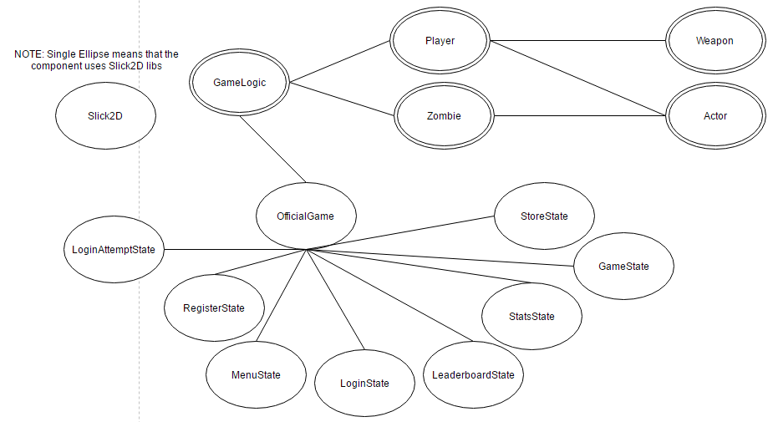

**System Decomposition**

Errors in LoginAttemptState:

* If using invalid characters, return a message box telling the user what the error is and how to fix

Errors in RegisterState:

* If username/email already exists, return a message box telling the username/email that the user already exists

Errors in StoreState:

* If user does not have enough money, return a message box telling the user that they do not have enough money